GUDLAVALLERU ENGINEERING COLLEGE

INFORMATION TECHNOLOGY
PROJECT NAME: FORECASTING THE SALES OF STORE

SUBMITTED BY: IT_AIML_A12 BATCH
Vamsipriya Adi(18481A1206)
Lakshmi Madhulika Anne(18481A1211)
Eekshitha Chaparala(18481A1220)
Gollapalli Divya (18481A1232)

INDEX
TITLE
- INTRODUCTION
1.1 Overview
1.2 Purpose
2. Literature Survey
3. Theoretical Analysis
4. Experimental Investigations
5. Flowchart
6. Result
7. Advantages & Disadvantages
8. Applications
9. Conclusion
10. Future Scope
11. Bibliography
12. Appendix
12.1 Source code
12.2 UI output Screenshot

1.INTRODUCTION

  - Overview:
Sales forecasting is an essential task for the management of a store. Being able to estimate the number of products that a retail store is going to sell in the future will allow the owners of these shops to prepare the inventory that they will need.
In this project, we are building a system that analyses the previous trends of sales which includes sales on various days and predicts future sales. The goal of this project is to forecast the sales of stores by using time series analysis. Here time series analysis algorithms such as RNN (Recurrent Neural Network) & LSTM (Long Term Short Memory) are used to analyze the past trends of sales of stores. Create and deploy flask-based web Application and integrate AI model to it.
The objective of the project is to build a web application where the user gives the last ten days' sales values and gets the prediction for the 11 th day which is showcased on UI.

  - Purpose:
The purpose of sales forecasting is to provide information that you can use to make intelligent business decisions. For example, if your forecast indicates a 30% increase in sales of products or services, you may wish to begin searching for larger business premises and hire additional staff to meet the demand.

2.LITERATURE SURVEY
To complete this project,you must require following software’s,concept and packages

- Anaconda navigator:

- Refer to the link below to download anaconda navigator

- Python packages:

- Open anaconda prompt as administrator
- Type “pip install tensorflow==2.3.0”
- Type “pip install keras==2.4.3”
- Type “pip install Flask”

3.THEORETICAL ANALYSIS
Block Diagram:

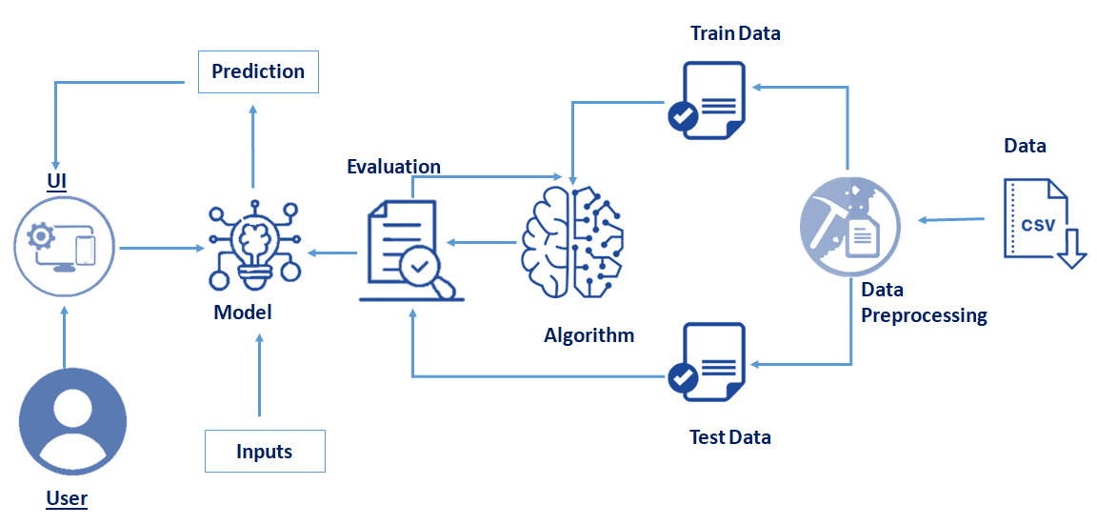

4. EXPERIMENTAL INVESTIGATIONS

Tensor flow: TensorFlow is an end-to-end open-source platform for machine learning. It has a comprehensive, flexible ecosystem of tools, libraries, and community resources that lets researchers push the state-of-the-art in ML and developers can easily build and deploy ML-powered applications.
Keras: Keras leverages various optimization techniques to make high-level neural network API easier and more performant.
Flask: Flask is a popular web python web framework,meaning it isa third-party python library used for developing web applications.

5.FLOW CHART
Project Flow:

- User interacts with the UI (User Interface) to enter the data of the previous 10 days to get the future prediction
- Entered data is analyzed by the model which is integrated
- Once the model analyses the input the prediction of the next day is showcased on the UI

To accomplish this, we have to complete all the activities and tasks listed below
- Data Collection.
- Data Preprocessing.
- Model Building
- Import the model building Libraries
- Initializing the model
- Adding LSTM Layers
- Adding Output Layer
- Configure the Learning Process
- Training the model
- Model Evaluation
- Save the Model
- Test the Model
- Application Building
- Create an HTML file
- Build Python code

6.RESULT
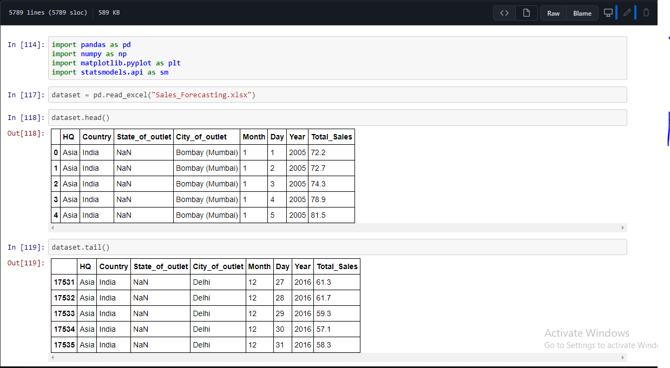

7.ADVANTAGES &DISADVANTAGES
ADVANTAGES:
- Useful in forecasting sales for industrial products, consumer, durables and new products
- Relatively inexpensive and fast
- Alignment of Strategy and Results
- Opportunities Adjustments

DISADVANTAGES:
- Difficulty getting a panel experts
- Longer time for getting consensus
- Uncertain environment

8.APPLICATIONS

- Shopping malls
- Book store
- Medical store

9.CONCLUSION
- Know fundamental concepts and techniques of time series forecasting and LSTM
- Gain a broad understanding of time series data.
- Know how to split the data for time series forecasting.
- Know how to build a web application using the Flask framework.

10.FUTURE SCOPE
Sales forecasting allows companies to efficiently allocate resources for future growth and manage its cash flow. Sales forecasting also helps businesses to estimate their costs and revenue accurately based on which they are able to predict their short-term and long-term performance
11.BIBLIOGRAPHY
https://youtu.be/pCuV_7H2vyQ
https://www.neuraldesigner.com/solutions/sales-forecasting

12.APPENDIX
12.1 Source Code:

12.2 UI Output Screenshot:

